Report Web design

Louis

LE GATT

Home page(with disclaimer):

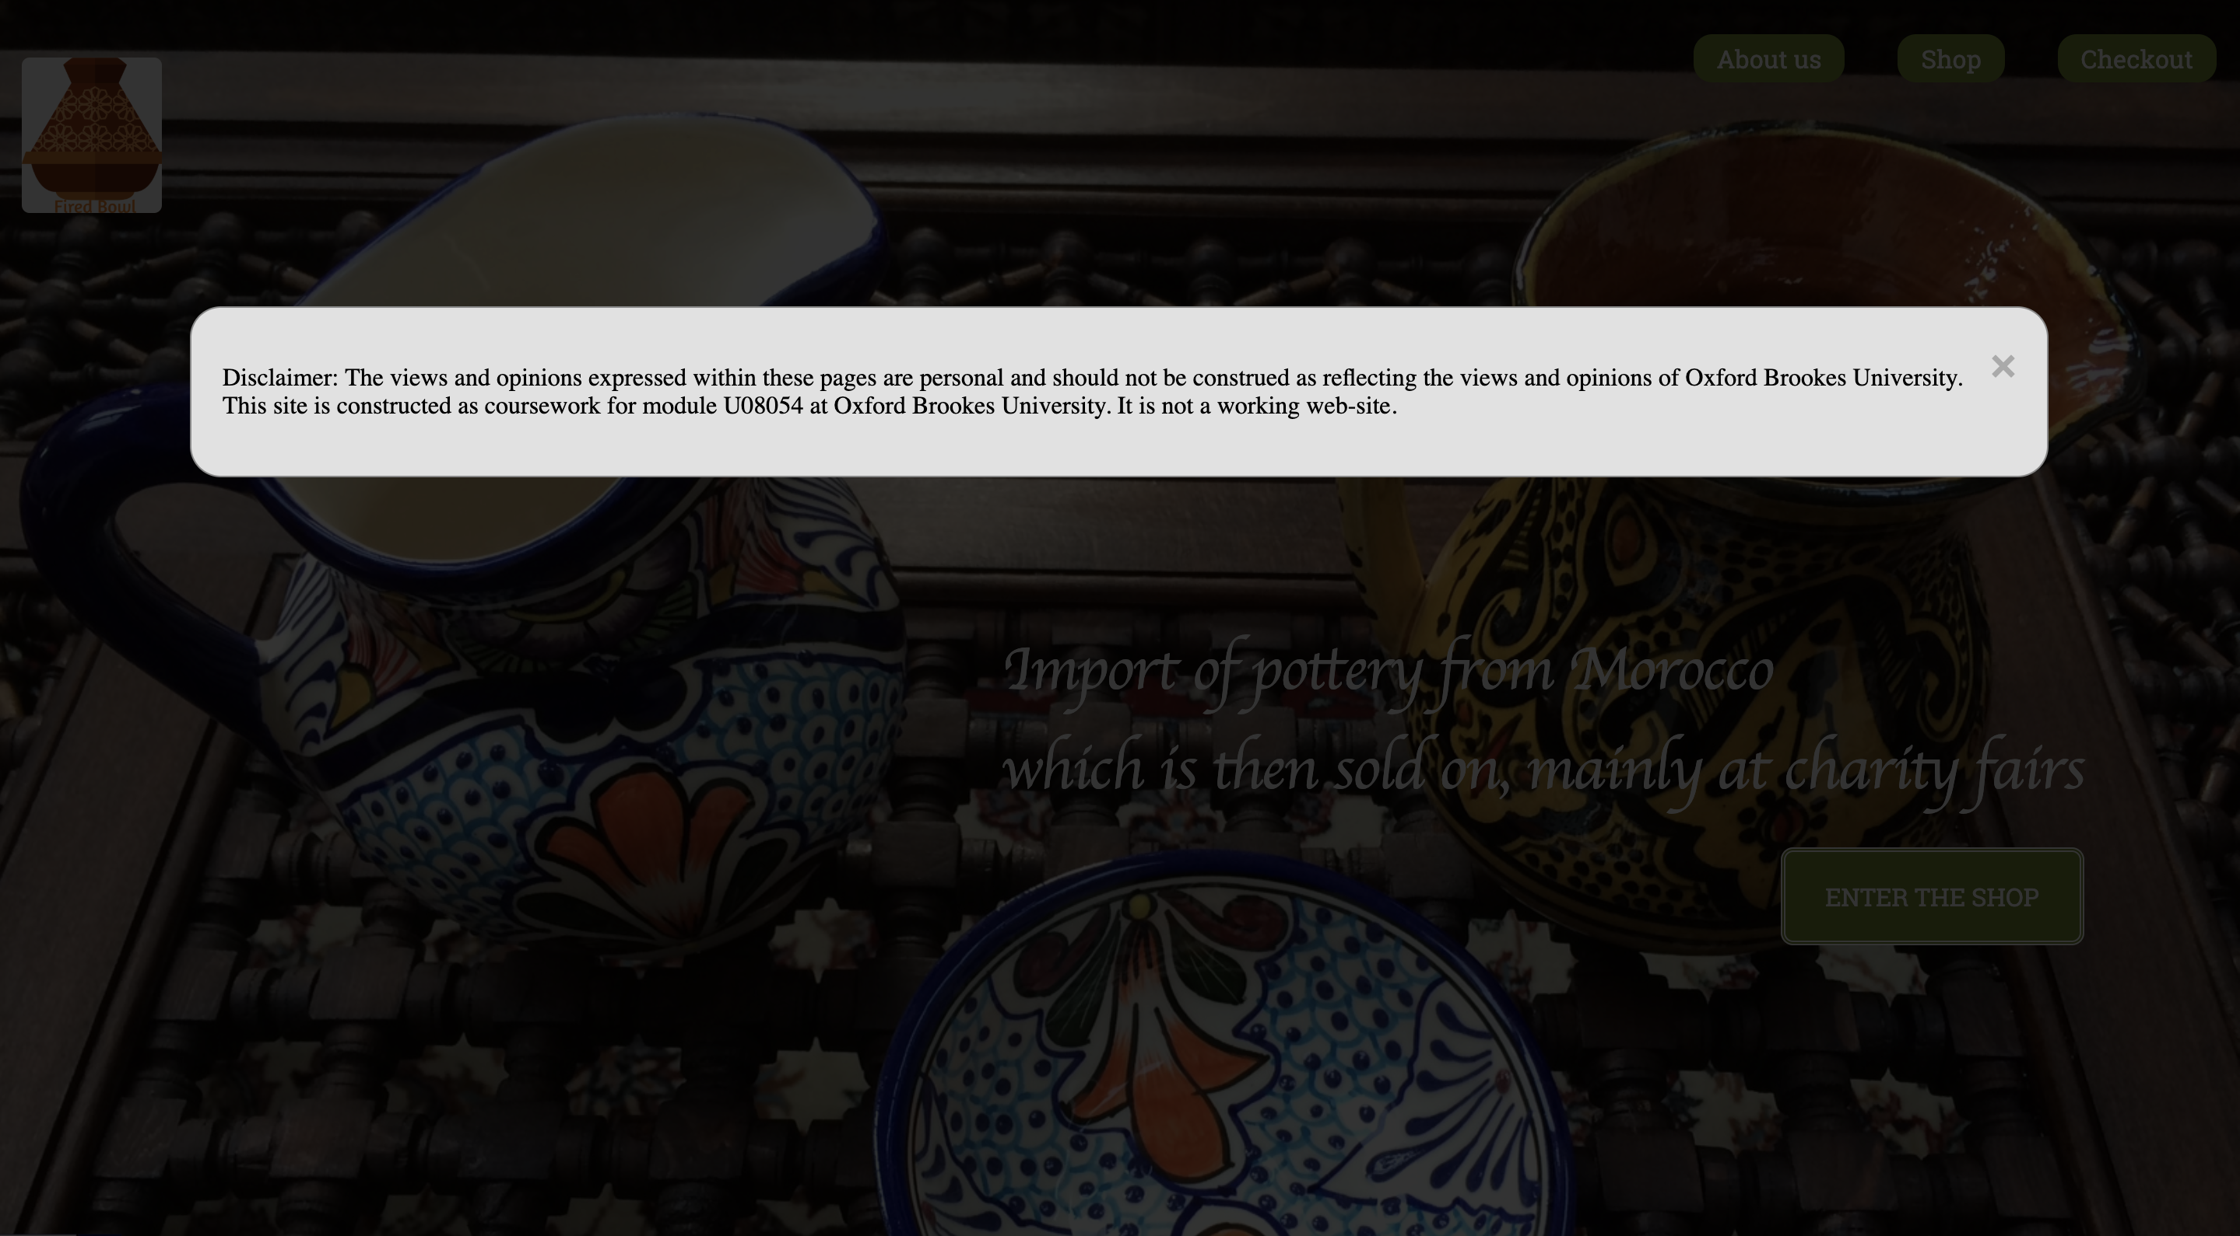

This is the disclaimer of the website on the Home page. It’s a pop up so the user can click on the X or out of the box to make it disappear. This one cannot be missed and it’s very fast to load.

Home page:

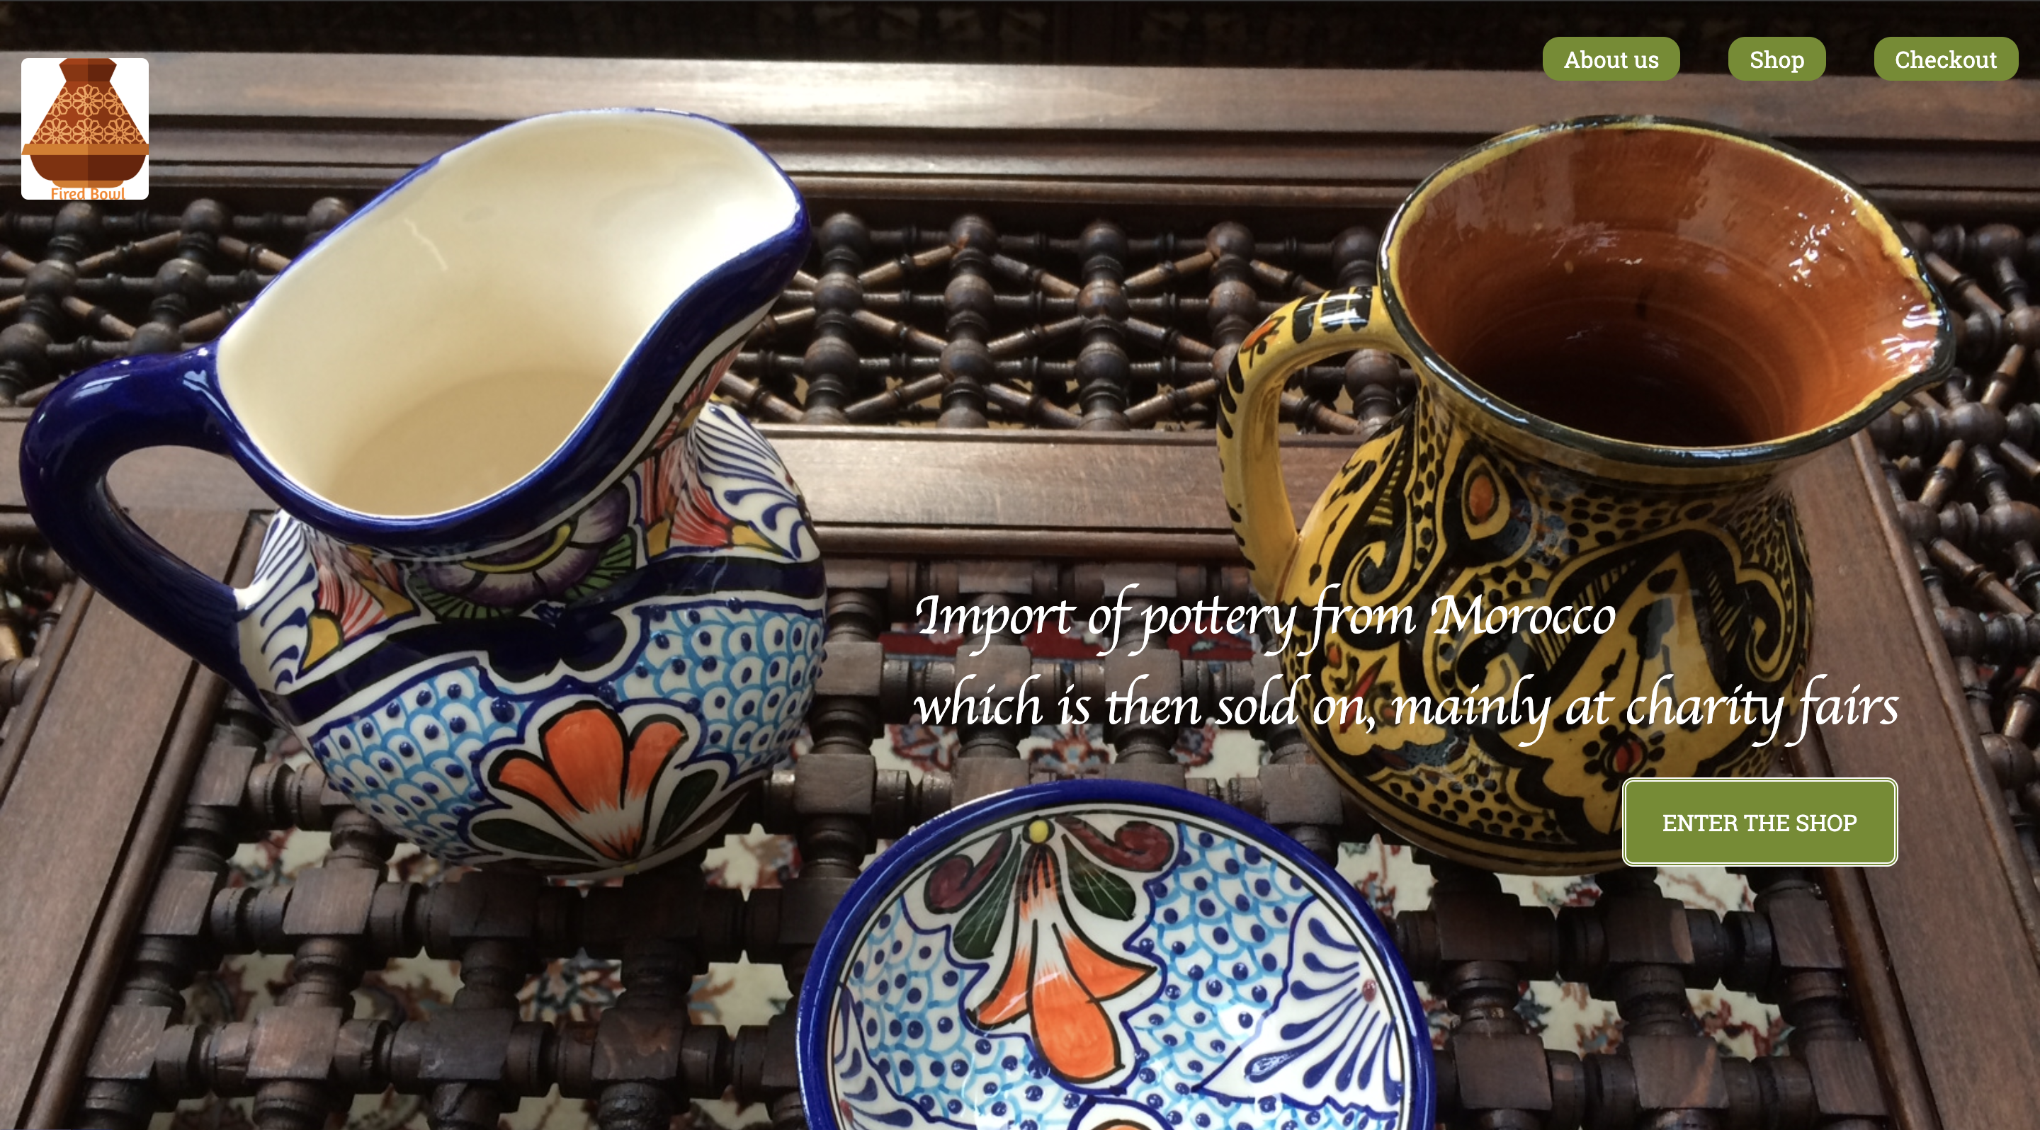

This is the Home page. I decided to have a picture of products on the background. That will answer to the question “what”. Then there is a little description using a different font to make it more stylized and to answer the questions “what” and “where”. The logo to the top left of the page give to the customer the name of the company and the logo and to answer the question “who”. On the top right of the page there are 3 buttons to access to 3 pages “about us”, “shop” and “checkout”. I had one more button to guide the user directly to the shop (which is the most important part of the website) just below the little description. This page is clear and easy to understand with the different buttons to access to other pages of the website.

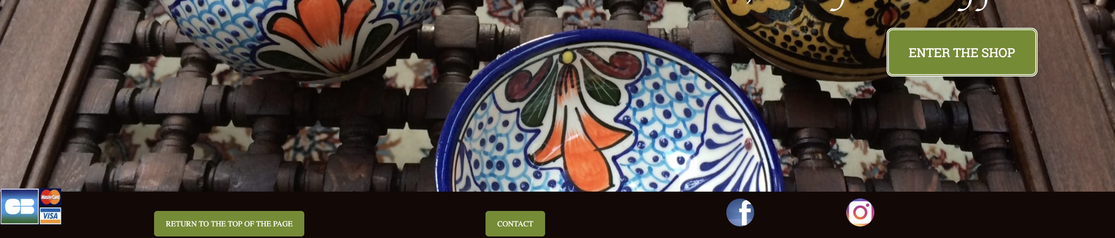

This is the footer which is the same on all the website. There are 2 logos to the right side where you can click on them to access to the social media pages of the company. You have also a button to access to the contact page where you will find more information to contact the company. And finally, a button to go back to the top of the page which is very useful on the product list page.

Product list:

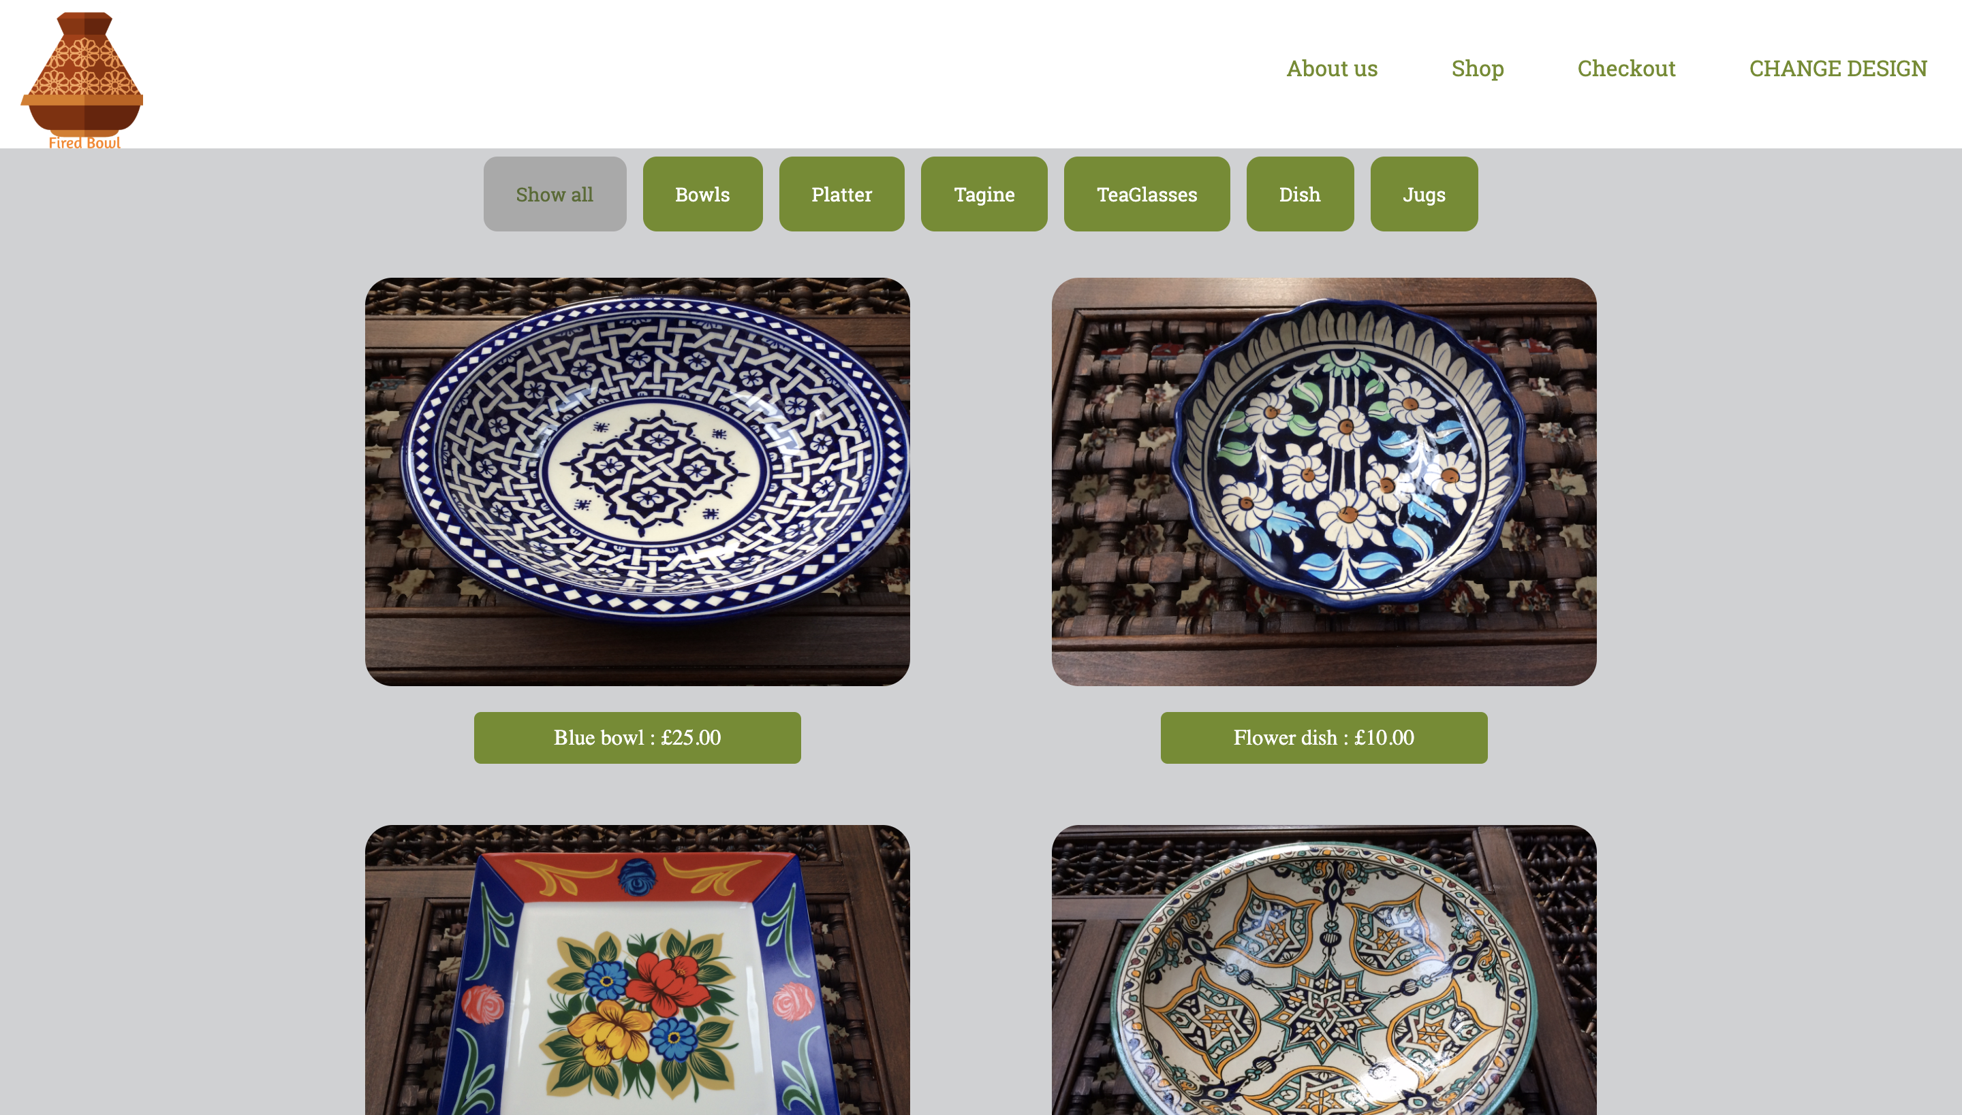

This is the product list page. As you can see there is the same navigation bar in white this time. So there are the logo, and 4 buttons. I add one more button which is a button to change the design of the page. Then there are 7 buttons to sort the list of products and to find more easily what the customer search. I used w3school website to understand how to do the sorting buttons. Then the list of products. Product’s pictures are big enough to see detail on the product without click on it. And just below the picture there is the name and the price of the product. Finally to the end of the page you can find the same footer as the Home page.

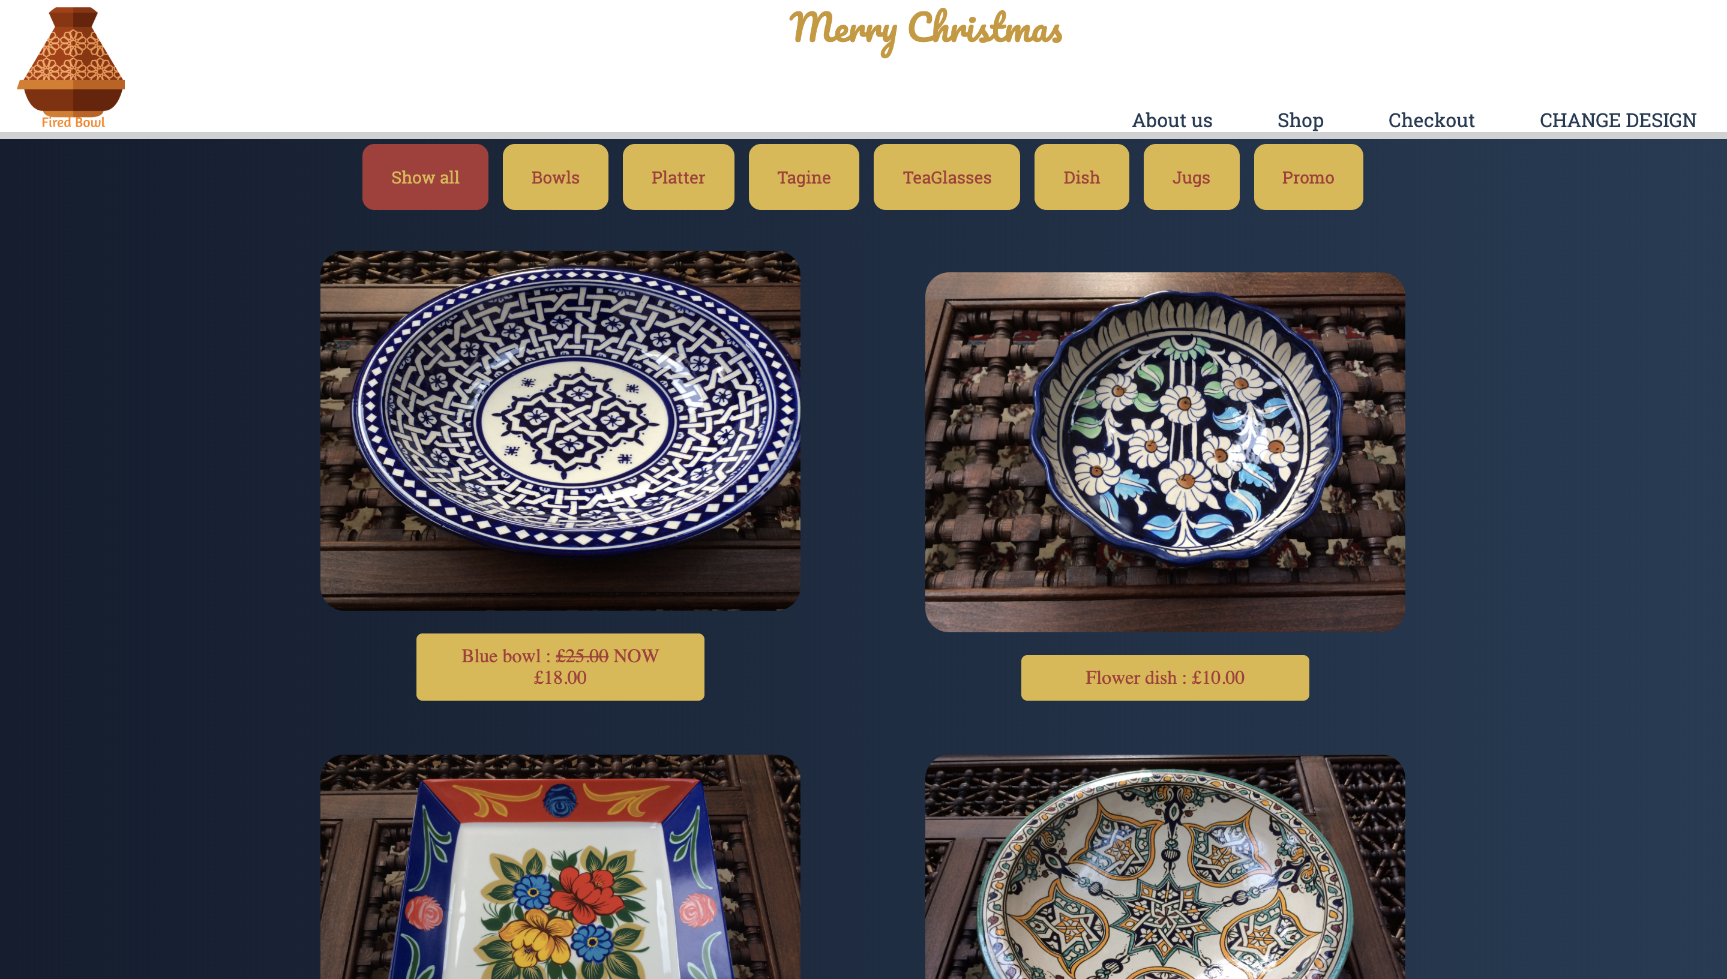

This is the same page but with the second design. As you can see it’s a Christmas theme. There is a “merry Christmas” on the top of the page with a fancy font. I change the background color to a dark blue and a gold color on the different buttons. I also decided to that there will be sales on Christmas that’s why the Blue bowl in now at 18.00.

Product page:

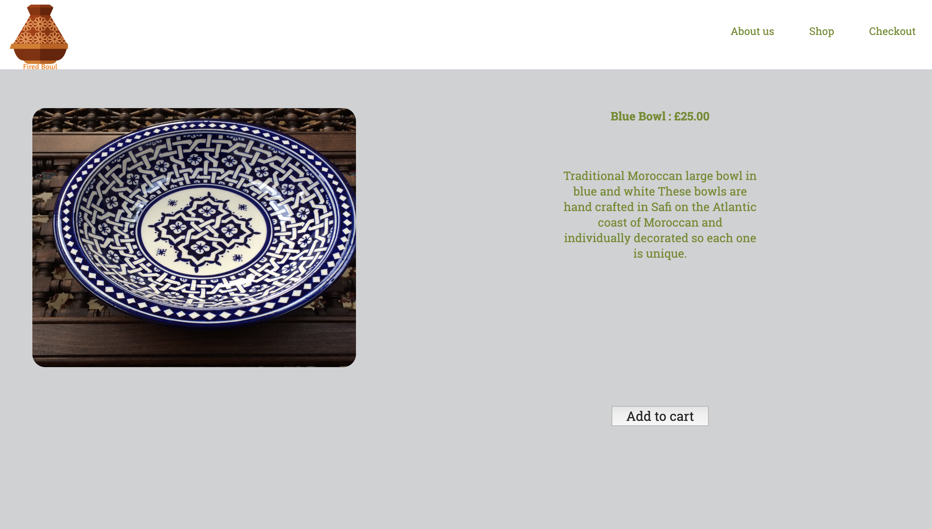

This is the product page. The picture of the product is a bit bigger than in the product list page and you have the description of the product on the right side. You can also add this product to the cart because it’s an e-commerce website. There are the same navigation bar and the same footer as everywhere on the website. All the product pages have the same design as this one.

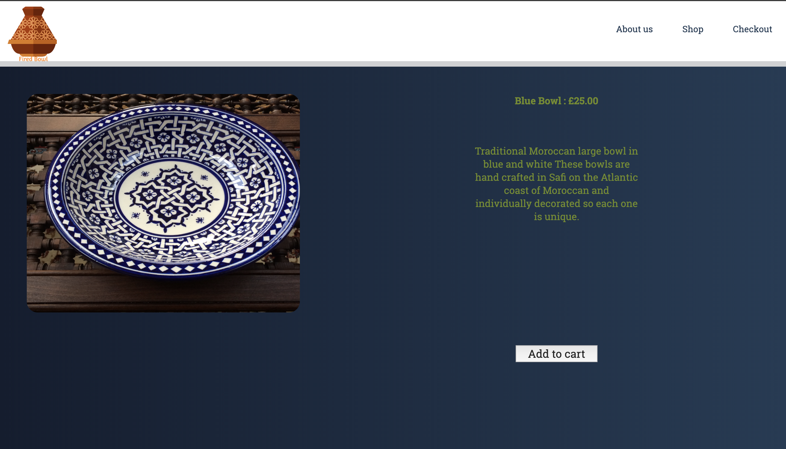

This is the same product page but with the second design.

About us page:

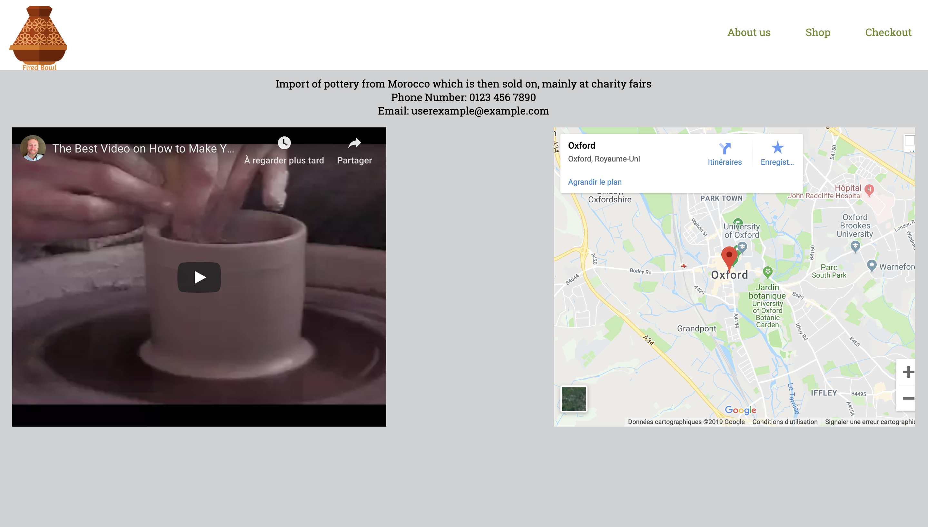

This is the page to have more information about the company. There is the same little description as in the home page, the phone number and the Email address.

I also add a video where the company can show how they make pottery and a map to show where is the company. This page is relatively easy to understand for old audience. In fact you have every information on the page. You can move on the map to understand more easily where you are, and you have a video directly inside the website. Furthermore the accessibility is easy, you just have to click on the logo to go back to the home page.

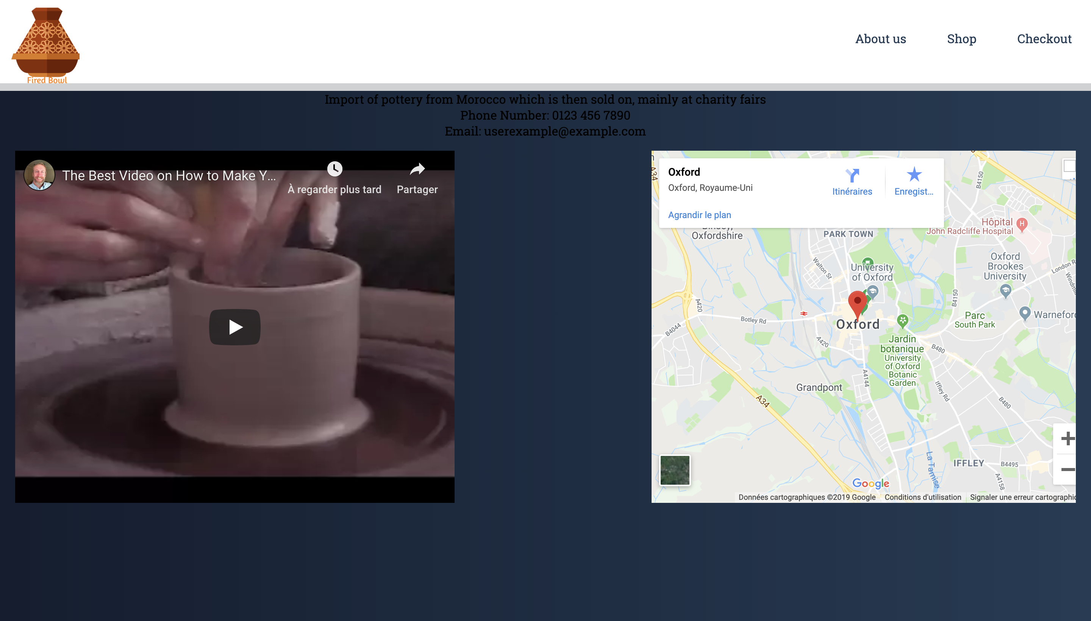

Contact page:

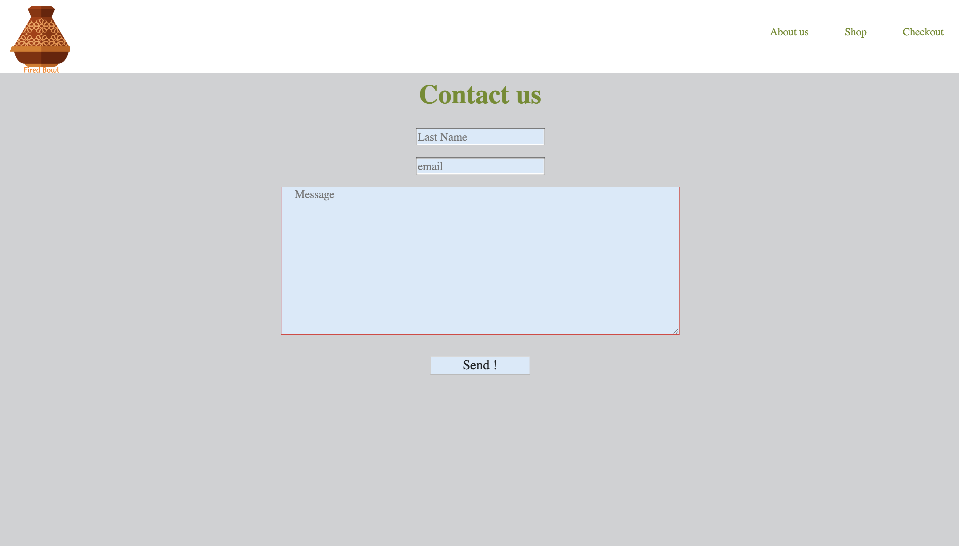

The contact page is only a form. So If someone wants to contact the company for any reason it’s very easy to complete this form which will be send to the company with your name and you mail address to answer to you.

Check out page:

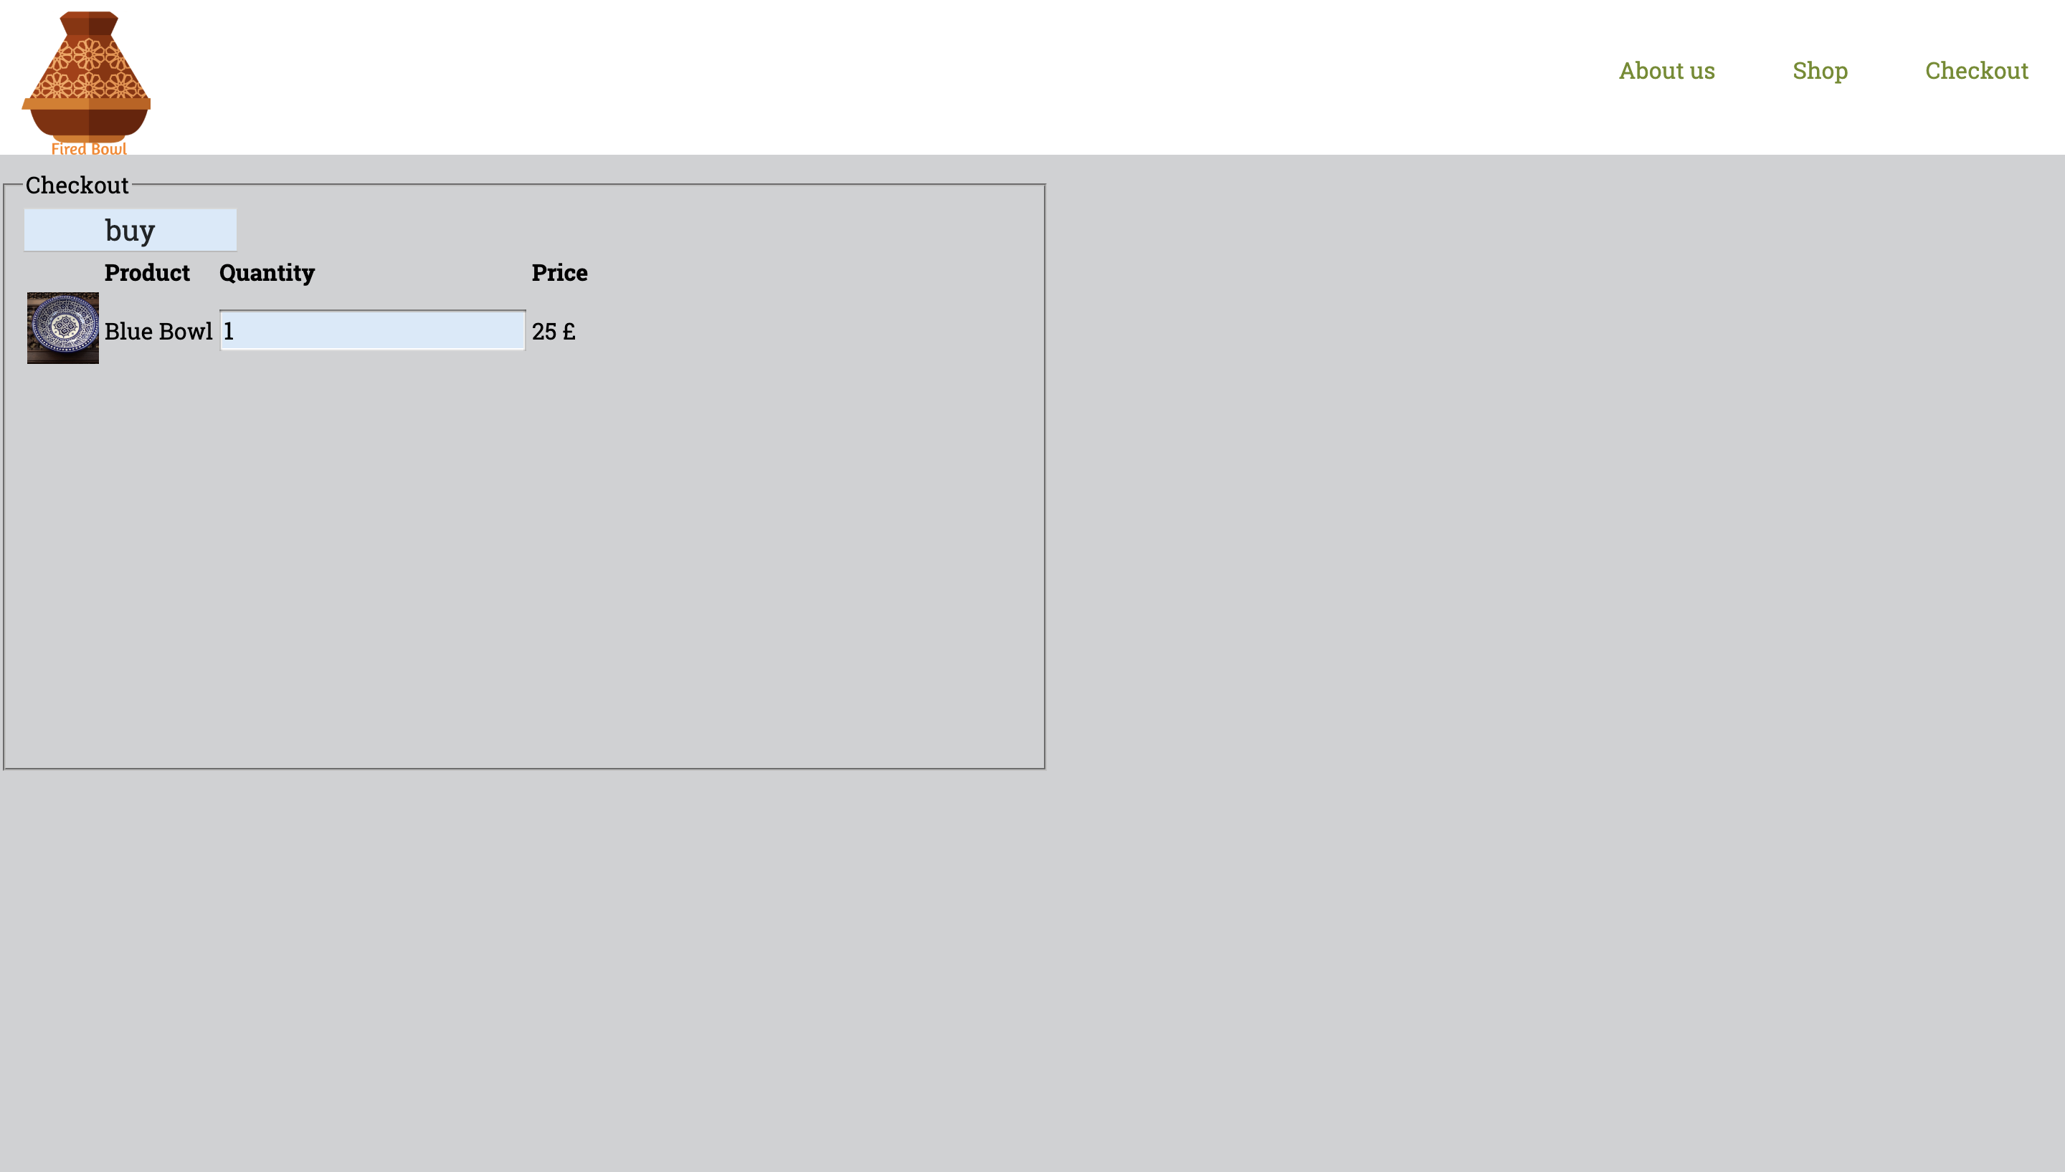

On this page you will see everything from you cart. There is a space where it’s easy to change the quantity of product you want, and the price will be update immediately.

Validation:

Home Page:

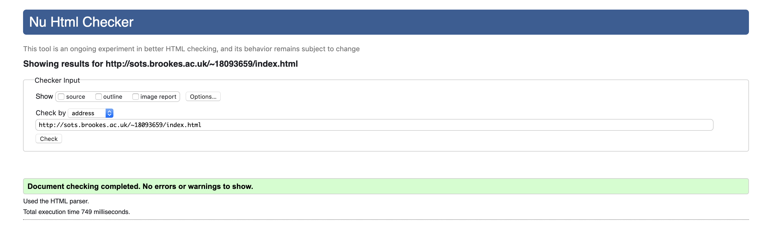

ProductList:

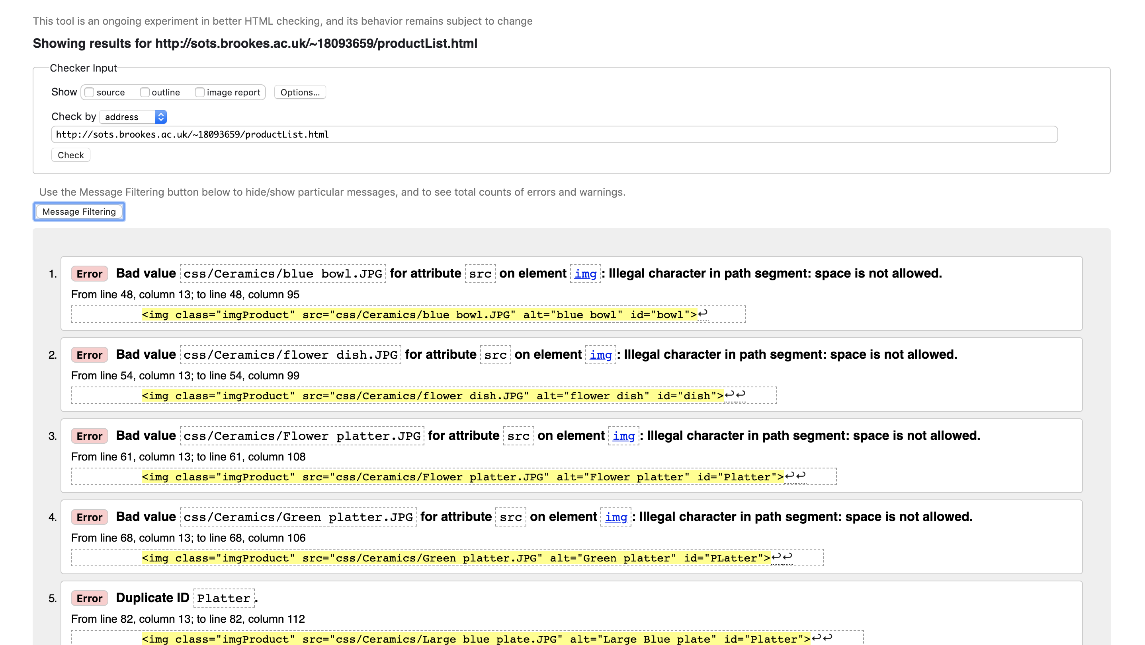

The illegal character error is due to the images’s name on the provided files where there are spaces which is illegal.

The duplicate ID error is because of the sorting function. I need to duplicate ID to sort my elements.

Product page:

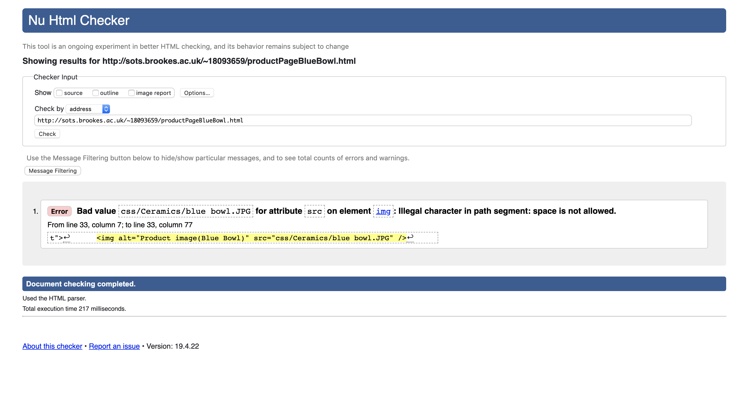

Same error due to the image’s name.

Contact:

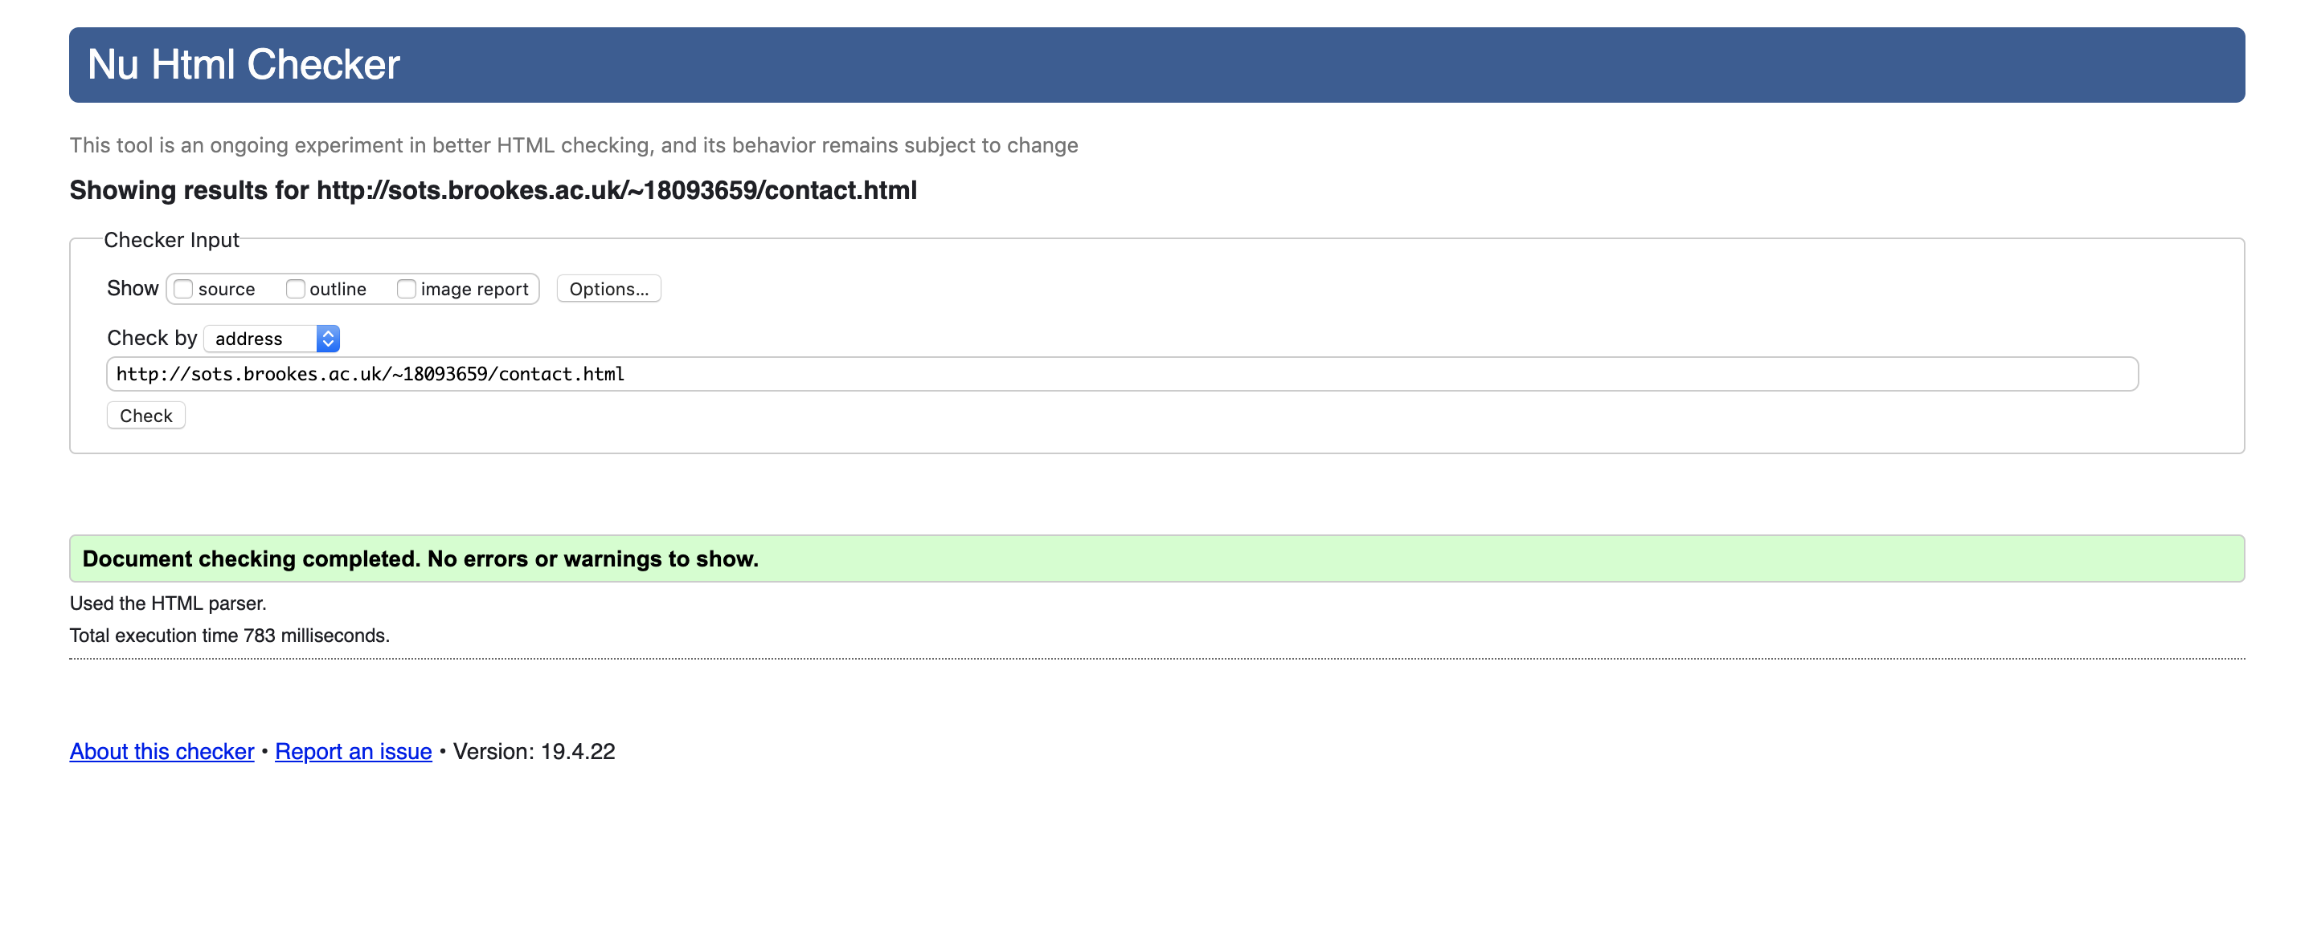

About us:

